Student
English 1010
Mrs. Payne
18 December 2017
Vegan Activism Is Out There
Veganism Overview and Context
As people of the world, we have come into 2017 with a large plate full of controversial issues. On and on, we begin to tear these topics apart, shred them with our teeth, and pull each other down during the process of proving a truth to natural ego and biases.
I placed myself in the center of 2017 argumentative topics and researched through veganism. In 1944, when Donald Watson created veganism, he also created a never ending and consistent, social war for animal rights. “Define Vegan” is typed into a search engine and we find, “A person who does not eat or use animal products.” As simple as our definition might sound, the proceeding websites will ultimately spread a voice to the world that eating animals and their bi-products is a serious sin. Whether our sources of the internet are mild or spicy, they will work hard to tear down the American diet. Memes will create a fun and effective voice, whereas articles, blogs, and documentaries give a serious tone and heartbreak from truthful statistics. Vegan activists will use every ounce of their energy to beat you with their words, and in their hopes and dreams, change your life. Here’s how.
Veganism Made Really Really Easy Summary and Review
Article Summary and Review
The Vegan Activist (unnamed), with over sixty-eight thousand subscribers on his YouTube channel, posted a video titled, “Veganism Made Really Really Simple”. Our title in itself holds truth to the entire video’s tone. One minute and fifty-eight seconds full of sarcasm, uncensored clips and simplistic reasoning.
Genre and Medium Strengths
Beginning this short film, we are given the statement, “There are two kinds of people in this world. There’s you, and then there’s people that aren’t you. Mind-blowing right?” Keep in mind, his background music is an elevator themed song. From the very start, viewers are given a giggle, which in turn, creates an impact of wanting more. The idea is given that everyone is going through a different day to day life, and as long as we remain mindful of others and they remain mindful of us, it will work out great. This is The Vegan Activist’s huge, yet secret, way of allowing the viewer to feel something. Every person wants to feel known and important, and so this opens the passage to the heart and emotions. He then states that animals (seen in this video and in real life) are just as important as the people around you. He continues on, blaming advertisements for the issue. He states, “We live in a world where we’re told it’s normal to commodify and eat animals, when we don’t need to. We’re told it’s healthy and happy and natural and sexy…”. A TV screen is shown where healthy is a science commercial, happy is McDonald’s, natural is cows roaming in the wild, and sexy is a half-naked woman, devouring a giant burger.
Genre and Medium Limitations
The Vegan Activist loses any person who has no interest is clicking a title about veganism. His jokes about the American diet will go ignored, and those with an ego larger than his power of words will be unsatisfied. Our audience must be able to take jokes easily, or else bye bye veganism and onto a different and more interesting topic.
Vegan Memes Summary and Review
Article Summary and Review
Memes, being one of many sources, are a way to not only make viewers laugh, like, and share, but it also chucks important topics and conflicts for people to give open debates. Blogs and social media sites really hold truth to sharing memes in order to float and become one with the social spectrum. These memes are not created for the offended to get defensive, but the common audience to giggle some and move on.
Teenagers are going to grasp onto memes as a means of social survival. Funny pictures, followed by a caption will allow friends to stay in touch over a common ground. Older generations will grasp on after the young and work to fit in.
Genre Medium Strengths
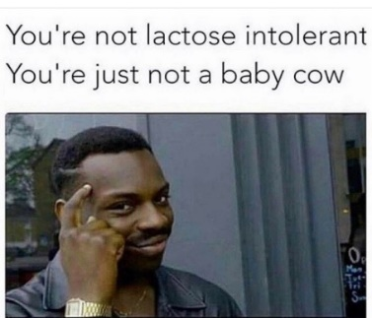
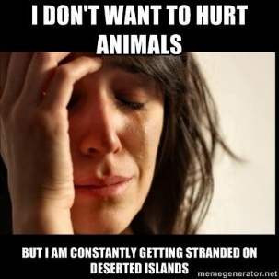
Our first meme is based on a very well-know, sarcastic statement. Vegans find themselves answering many common questions, including, “If you were stranded on an island with no plants, then would you eat meat?” Here is where we add a picture of a women crying, as the words sarcastically state that she is “always” getting trapped on an island.
Next comes a man sarcastically stating what is taught by society to be normal, is not so normal. Our creator is most likely offering his opinion, because of his annoyed biases. Lactose intolerant is very common, and here our author is telling people that no, they are just being dumb.
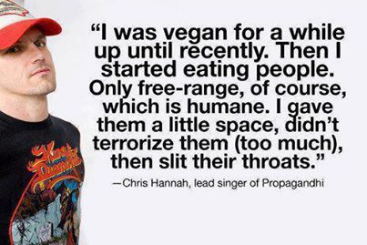
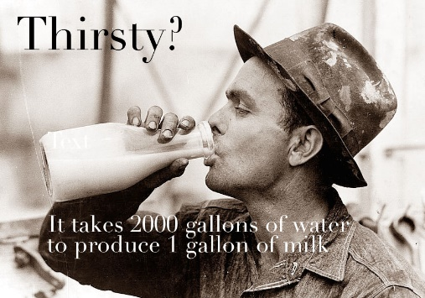
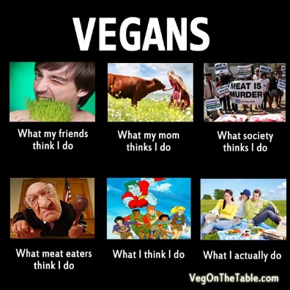
Vegans have a different diet, therefore creating a negative impact on the entire idea. Our author is standing here with a statement of pictures to prove his idea that veganism is not as weird as it’s made out to be.
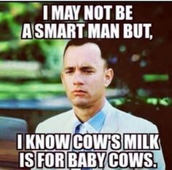
Here, our old fashioned photography of a man drinking from an old fashioned jug of milk automatically tells the facts that milk has been around for quite some time. Facts will give the audience an incapability to back their own opinion up. Environmentalists may look at this meme and think how crazy, maybe it really is time for a change.
The rest of our memes are sarcastic, seeing that most memes are sarcastic, we can reel our audience in with laughter and clarity.

Genre and Medium Limitations
Given a meme that only vegans will understand can really impact our change of mind for viewers who are not in the loop. When these captions make fun of non-vegans, they risk offending and losing possible patrons. People, as I stated before, do not want to be offended. Memes work well with an audience who can handle a joke, but those who cannot, might need to be offered a scholarly article or documentary.
Animal Agriculture is Choking Our Earth and Making Us Sick. We Must Act Now. Summary and Review
Article Summary and Review
A newly famous webpage, The Guardian, allowed two talented and skilled authors, James and Suzi Cameron to publish an article that will come to be a new way of vegan activism. In, “Animal Agriculture is Choking the Earth and Making Us Sick. We Must Act Now”, James and Suzi come up with a new way to create change in the way of life. Their discussion to viewers goes on about the idea that our environment is plummeting down and it’s up to the people to help it out. Most vegan activists inform their audience by stating how fat America is, or how badly the animals in agriculture are being treating. Here, they give much less given effort to offend the audience, and more effort causing them guilt for what they are incorporating to.
Genre and Medium Strengths
James and Suzi begin by stating some serious facts. “Raising livestock for meat, eggs, and milk generates 14.5% of global greenhouse gas emissions . . . It also uses about 70% of agriculture land, and is one of the leading causes of deforestation, biodiversity loss, and water pollution.” A mouthful to chew is immediate thrown into the readers face. There is no backing this up with an excuse, because it is exactly what it is. Our article here is going to continue with more environmental issues and eventually talk the reader into feeling bad and wanting to make a change. Following some guilt, the authors begin to touch on ideas of healthy living and a plant-based diet. Stating the fact that incorporating the typical American diet into your lifestyle will lead to a list of health issue and diseases, is huge. Our authors are smart here, and they understand that most people may not even realize how badly they are hurting, not just the earth, but themselves as well.
Comparing this to PETA, and huge vegan activist program, we create a much different feeling. PETA forces the idea of animal slaughter and animal rights. James and Suzi state absolutely nothing over the idea of animals. They only begin with the facts of agriculture and its negative effects. This can be helpful, because many people turn their heads at slaughterhouses. They simply do not have empathy. With this, they catch the attention of people who care for the place they live.
Genre and Medium Limitations
We can only change the minds of people who already want to make a change in the world and negative circumstances. A person who has no care at all, will most definitely cross out of the article and move on. With that, we are only going to have environmentalist who click on the link, for its title. Even though that is a great amount of readers and will create an impact of some sort, it will not reach out for the hearts of the other percentage.
Conclusion and Recommendations
War of any kind is a deadly game. Placing yourself in an entirely different world and pressing for others to follow is risky. One cannot simply open their choice of opinion, and automatically change the minds of the world. We are not capable of the power to form a robotic society.
As a viewer of The Vegan Activists quick film, “Veganism Made Really Really Easy”, one might become so intrigued with his facts and sarcasm, that they become one with it. Think deeply here though. His video is simple and quick and rarely might a person view his video and think, “Oh my goodness I must go vegan now. These animals have feelings too.” No. His video has less power with the length and laughter; it is mostly only going to allow the idea of veganism to sink into viewer’s minds for a moment in time. Nonetheless, The Vegan Activist is easily overcast by a Documentary or PETA ad.
In “Animal Agriculture is Choking the Earth and Making Us Sick. We Must Act Now”, the statements and environmental hazards given will begin to sink that much more deep than a couple minute YouTube video. As James a Suzy give their list of serious reasons to go vegan, they take down a meat eater’s mindset. Though, only a meat eater’s mindset who cares about the environment and their own health. James and Suzy limit their progress by touching on only a few issues. Being a part of The Guardian, they begin to attain their hopes, because The Guardian is beginning to become a more frequent and popular link on social media webpages.
Lastly, we click our like buttons to memes. A picture and one sentence has a large impact on mostly any person. These sentences come in all sorts of ways, too. Touching every base in the human mind, memes win at reaching the soul for all viewer in a way that can change their mind. One vegan, on social media, can share their favorite memes and ultimately reach every person on their friend list. Being blasted all over, there is no way for a meat eater to miss these important messages. Here, we’ve got a huge network of vegan activism, where the creators don’t even have to try that hard. Memes are great for people who don’t have time for three pages of environmental issues. They also work when a person does not care to watch an ad and wait for a video to load. Attention is immediately connected when seeing the amount of water used for so much meat. Intrigue from the very beginning is a key step to a success in the vegan activism community.
Finding a source correct for the viewer is important, but not impossible. They can trigger your heart or your mind. Simply choose your poison and enjoy.

Works Cited
Cameron, J. S. (2017, August 26). Animal Agriculture is Choking the Earth and Making Us Sick. We Must Act Now. https://www.theguardian.com/commentisfree/2017/dec/04/animal-agriculture-choking-earth-making-sick-climate-food-environmental-impact-james-cameron-suzy-amis-cameron
“I Don’t Want to Hurt Animals. Meme.” Ecorazzi.com, Ali Berman, 3 May 2013. http://www.ecorazzi.com/2013/05/03/12-of-our-favorite-vegan-and-animal-rights-memes/
“I May Not Be a Smart Man, But I Know Cow’s Milk is for Baby Cows. Meme.” M.favim.com, OwlPurist, 5 March 2016. https://m.favim.com/image/4271905/
“I Was Vegan for a While, Up Until Recently, Then I Started Eating Humans. Meme.” reddit.com, i.imgur. https://www.reddit.com/r/QuotesPorn/comments/2bof1b/i_was_vegan_for_a_while_up_until_recently_chris/
“Veganism Made Really Really Easy.” YouTube, uploaded by The Vegan Activist, 17 November 2017, https://youtu.be/jEc7MBJ2adQ.
“Vegans. What People Think I Do, What I Actually Do. Meme.” Wonderblogger.weebly.com, My Wonder, 18 August 2014. http://wonderblogger.weebly.com/blog/what-being-vegan-taught-me
“You’re Not Lactose Intolerant, You’re Just Not a Baby Cow. Meme” Me.me.com, Chakabars, 9 February 2017. https://me.me/i/chakabars-youre-not-lactose-intolerant-youre-just-not-a-baby-9399625
“2000 Gallons of Water to Produce One Gallon of Milk. Meme.” Paleoveganista.com, Kelsey, 20 October 2014. https://paleoveganista.com/2014/10/10/vintage-vegan-memes/

