Men need to read this thread about all the things women would do if men had a 9pm curfew

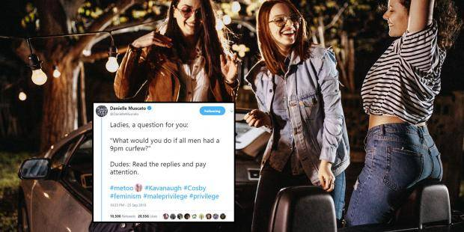

Women have been coming out in the droves to share their experiences with sexual assault.
It is heart-breaking, because of its prevalence, but also a testament to the growing power of the female voice.
And it hasn’t been easy – of those who accused powerful men of sexual misconduct, many have been scrutinized, many had their testimony cast into doubt and many were blamed for inviting the abuse with the way they dressed and the circumstances they found themselves in.
It is a beautiful, though still dangerous time to be a woman – especially in certain parts of the world.
With that in mind, activist Danielle Muscato posed a simple question to her Twitter followers: What would you do if all men had a 9pm curfew?
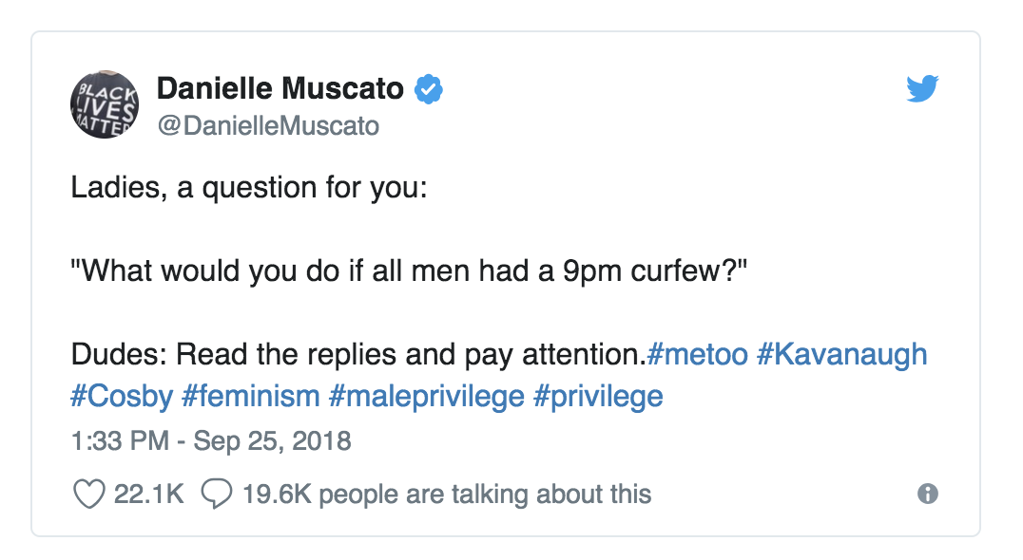

The answers are pretty heart-breaking.
Women wrote that they wanted to do simple, innocuous things like walking in the evening and going to the shops.
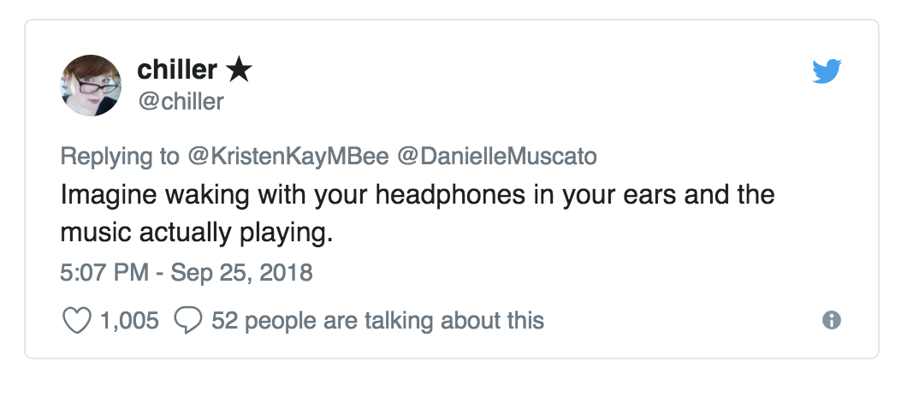
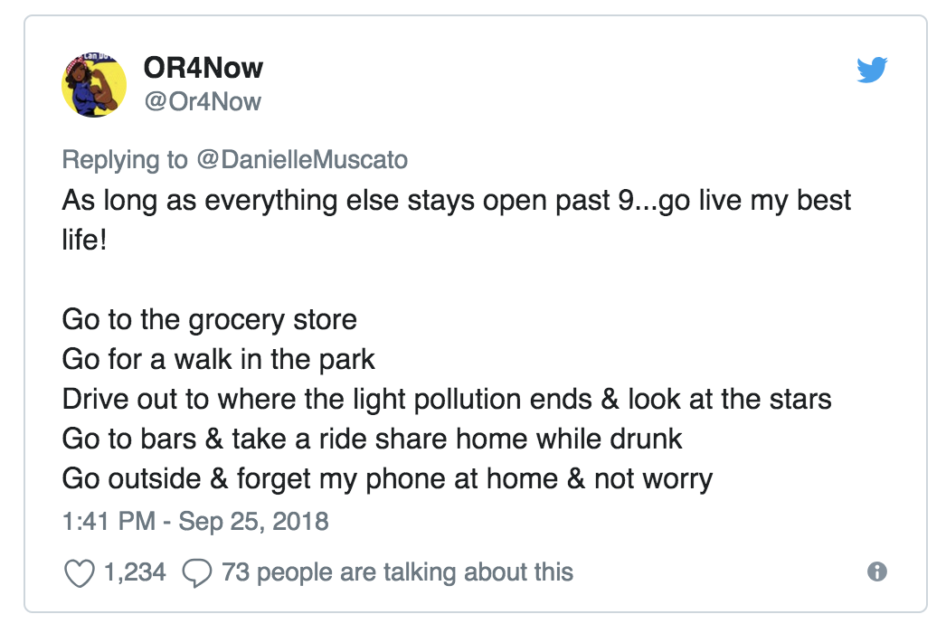
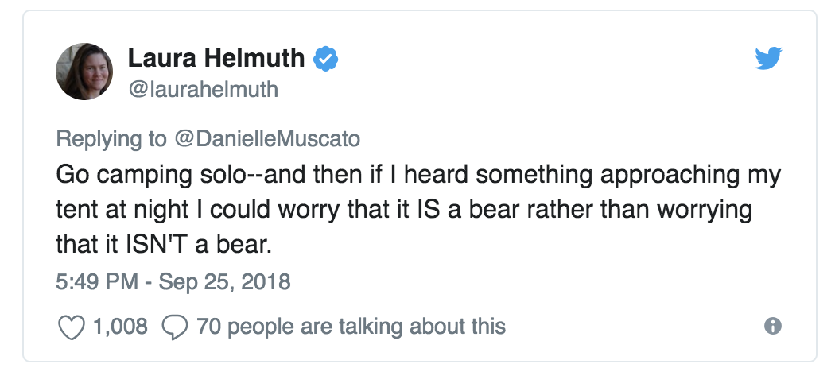
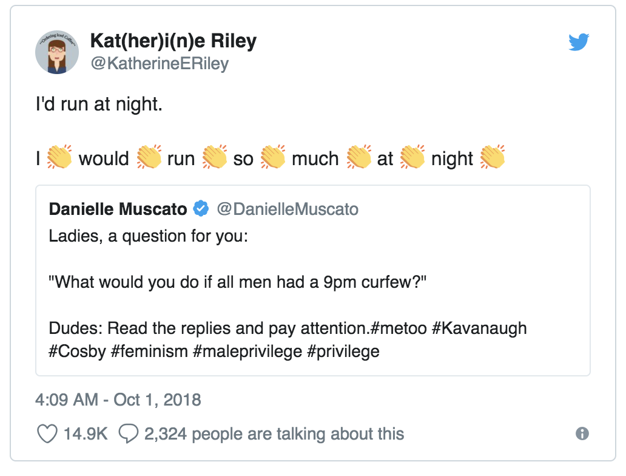
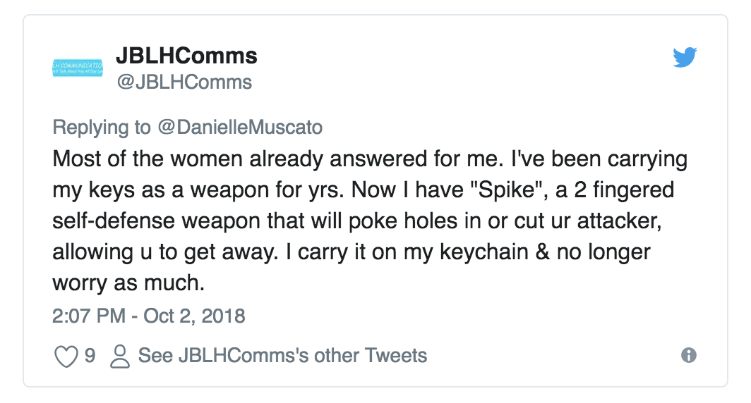
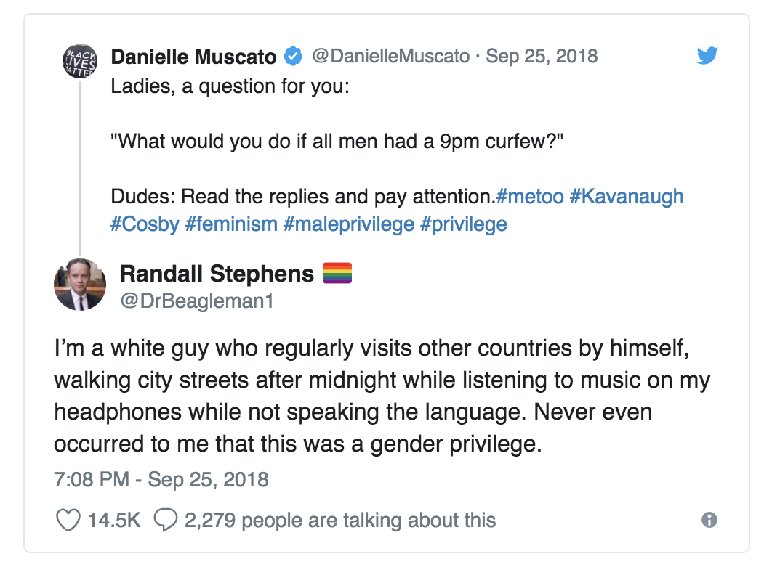
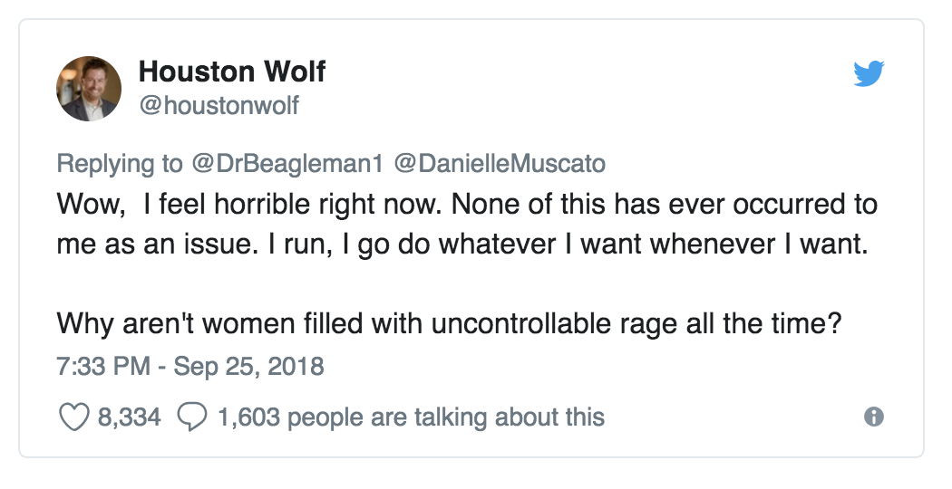
For women, the thread became a shared act of unity, and for men, it is a place to learn about their privilege.

