Student
English 1010
Mrs. Kasie Payne
18 December 2017
Russian Roulette
A woman in the United States has a 1 in 262,000 chance of being killed by a shark (Human Shark Bait). Due to these attacks, we cull an estimated one hundred million sharks per year to keep our beaches “safe” (Andrew). A woman in the United State has a one in six chance of being raped. Only sixteen percent of rapists will be imprisoned. Maybe we are worried about the wrong predator? One in six. Two in twelve. Three in eighteen. A woman has a higher chance of surviving a game of Russian roulette, than getting through their lifetime without a man forcing them to have sex. Recent events and news stories have caused an outcry among women, and awareness and analysis of this rape culture—and realizing many men don’t even realize or understand it-- has been spread through dozens of different genres and mediums, each having their own strengths and weaknesses, but all attempting to describe and prevent the day to day struggle of what it’s like as a woman to play Russian roulette without their consent.
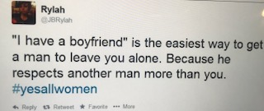
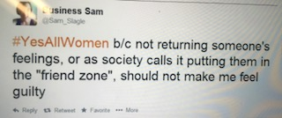
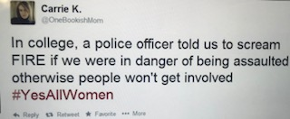
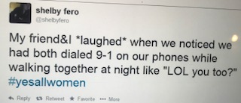
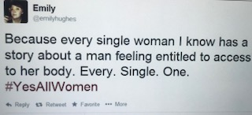
The internet has spread throughout America at an exponential rate, with nearly every single home having access to the world wide web today. Social media was quick to follow, and for the first time in history, a common person’s story can be heard by the masses. The sudden awareness of millions of women who have had the same crappy experiences, has spread awareness, and with it, the suddenly realizing men have no idea what the rape culture is, nor do many of them necessarily care. After going through a cycle of emotions (mostly anger, some tears, crushing injustice, blackening spite, overwhelming hopelessness, and back to anger) multiple times, some women have decided to take on a seemingly impossible, and infinitely frustrating, task: make men realize women are people, and rape culture is not okay. If only we could make this announcement over and over again in every single public place, maybe our daughters would have a chance. Maybe. Unfortunately, we can’t do this, but one way of getting the point across is through social media. Specifically, Twitter. In 140 characters, women attempt to share what rape culture is, and how it effects women through the #YesAllWomen Twitter chain. In Caleb Reading’s “The Most Clever And Thought-Provoking #YesAllWomen Tweets” on UPROXX, he compiles the best of these tweets. Because with a 1 in 6 chance of being raped, yes, all women have had an experience of some kind of sexual assault or have at the very least been educated on how to protect themselves to make sure it’s the next vulnerable girl. Hopefully, the bullet is in the next chamber, not the one pressed to their own head. They have 140 characters, shared with dozens to thousands of followers, to define the thing shaping their lives. They have to fit something that could compose the longest book in history, into 140 characters. And somehow, many of them have managed to do it in informational and powerful ways, while also spreading it to thousands of people, delivering the message that men are not entitled to women’s bodies. Using the same hashtag allows people to search and find tweets all relating together, and therefore each 140 characters adds up to enough experiences and information to fill a novel. However, it is still a bunch of disconnected tweets with little to no background and no ability to defend or back it up. Pieces of stories and opinions are lost in order to reach the masses.
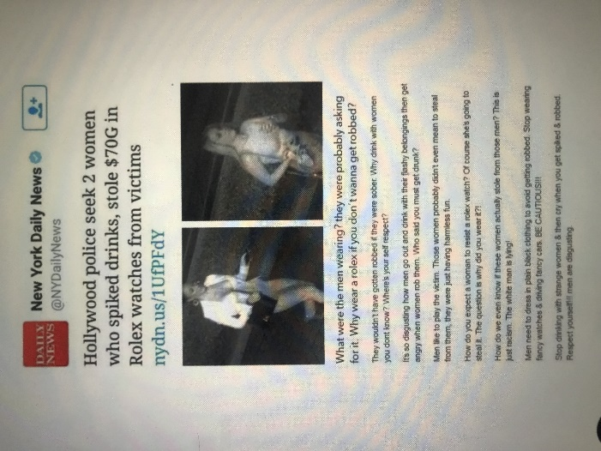
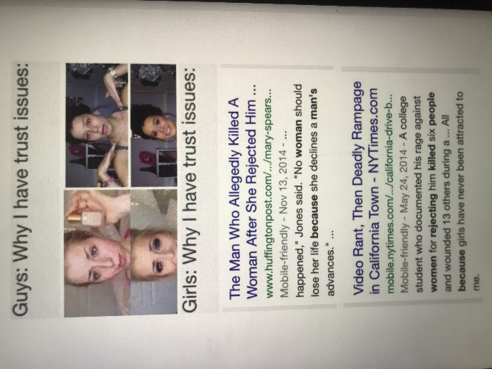
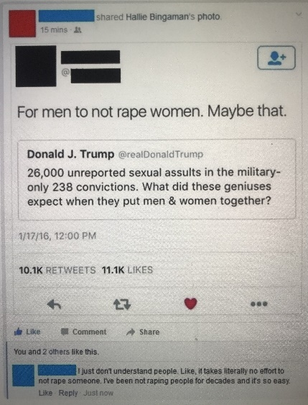
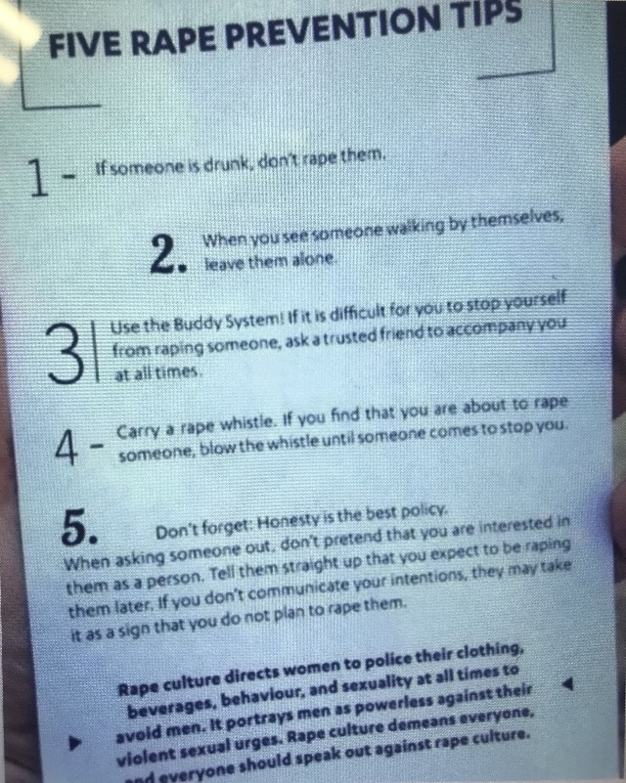
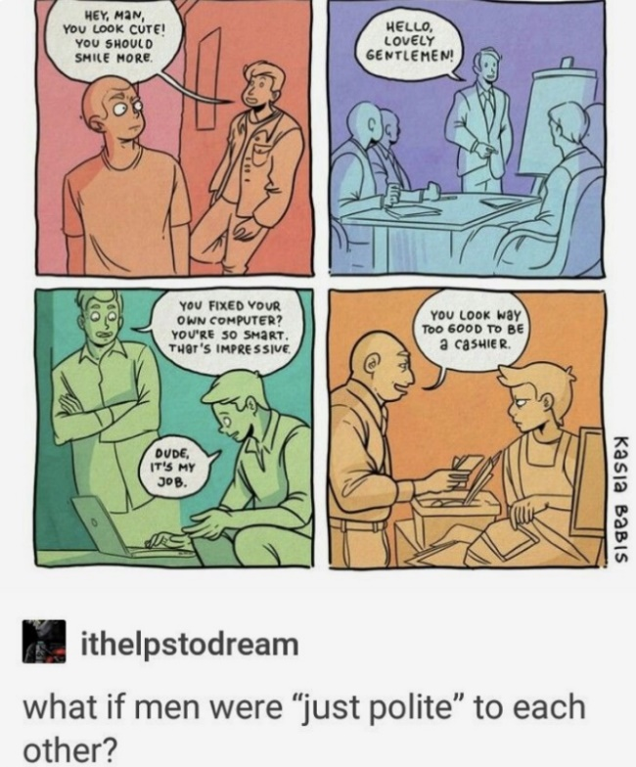
One of the best qualities of the internet is the ability for thousands of people to come together and collectively make fun of things. Sarcasm, exaggeration, and cynical views on daily activities all come together so any person can find something to laugh at. A major format for this humor is through memes. Memes widely range in topic, format, humor, and information, but all have a common goal: make people laugh. Thousands of people easily see a popular meme at any time, and new memes are made seemingly every second. The generally cynical and sarcastic nature of the memes can break down and put even the most complex of things in its place, including rape culture. Using a collection of memes with the search term “Rape Culture” through Pinterest, there are hundreds of memes giving different views and aspects on rape culture. Using a blend of humor and information, it gets the point across in a way to make people feel stupid for being confused about it in the first place. It makes it relatable and understandable, which is currently one of the biggest problems facing the removal of rape culture from our society. They don’t understand. The fact is, it seems people can only understand it if put in plain and simple terms, and many aren’t even interested in it unless it is funny. We wouldn’t want to feel bad when talking about rape. Make me understand in a way I can still fake smile. This topic is too serious, so many people will only pay attention if its lightened it up. This is where memes can become effective. Although not entirely appropriate to laugh at something so serious, it reaches a wide audience in a way anyone could easily understand. This is the point of memes, because in order for it to be effective it has to be understood by everyone, or it will never become popular, never seen, and can never be impactful. Although not exclusively, this does mean many have to be directed at men in a way that all men can understand. Most women are already aware of the thing shaping and defining their life, the trick is getting the men in on it too. The memes must cater to men to make them understand, because otherwise change will come painfully slow. Men have asserted themselves as dominant for hundreds of years. Women have come a long way and made a lot of progress, and continue to work and gain ground, but ultimately if the men can’t understand and see woman as more than sex objects, then rape culture will never go away. Half the population will continue to objectify and support pornification of woman, and support the culture not penalizing rape. Half the population will not understand the other half as people. Russian roulette becomes far less severe when it’s not human beings at stake. This is why although sometimes inappropriately humorous, memes become effective in relating to everyone.
Speaking of understanding each other, sometimes it goes the other way. It’s hard for women to understand how in the world rape is even a thing. As women, knowing our own beliefs, passions, and goals, it’s hard to see how men don’t. In Allan G. Johnson’s article “Why Men Rape” in the Voice Male, he explains this idea. Combining experience and research, he pins down what he believes to be the root cause of the cycle of rape in his essay. His article is professional and analytical, using fact and observation to come to a conclusion on the topic difficult to object too. It is able to reach a large educated audience through its publishing and inclusion in online college libraries. However, it is limited because the entire population does not have access to it. Only literate people interested in this topic would be able to find it and have access to the information. This limits the amount of impact and change it can induce, although it would be considered very accurate and trustworthy due to it being a “scholarly article”, meaning the people it did reach would most likely be very impacted by the information filled with logic and hard evidence. This makes for a very persuasive article bringing understanding and support to the conclusion of it, but it can also have the effect of making a problem largely mental and emotional impersonalized and cold. If it were able to reach a larger audience, it would be effective and a great catalyst for change, because a specific cause is finally identified and understood in a trustworthy way. This is big in forming opinions about this, which can easily be tainted by emotion and privilege, but Johnson broke down and defined in a way anyone, especially women, can understand and now pinpoint in daily life.
In any case, only getting information on the topic from one method is a dangerous way to form an opinion. Due to the popularity and far reaches of the internet and social media the short messages addressing rape culture, although important to putting the problem in perspective in serious and humorous ways like in the collection of memes and Reading’s collected tweets, does not have as in-depth analysis and background as other sources might, like Johnson’s article. However, only going to the scholarly articles or statistics can cause a lack of emotion in the matter. Rape has a major impact on emotional and mental health, often causing serious long-term issues, so in dehumanizing it and pulling it down to simple statistics can in some ways makes the cause lose some of its potency. It’s in understanding it is real human beings being affected by this that the eradication of rape culture becomes truly urgent.
Likewise, basing opinions and beliefs on the topic on single events or experiences can cause opinions to be tainted in different ways. Often it is colored by personal experiences and beliefs, and the true severity and reach of rape culture can be diminished. It’s in the facts and logic the reach of rape culture is discovered, and it’s in the stories and events motivating people to fight and remove it. Statistics can be powerful when backed by personal events and opinion, but alone neither can fully describe a culture developing over thousands of years and is ingrained in even the smallest pieces of a person’s life. Using sources with as many different features and qualities to create an informed opinion is extremely important to understanding all parts of such a complex and far reaching issue.

Works Cited
Andrew, Elise. “How Many Sharks Do Humans Kill Per Hour?” IFLScience, IFLScience, 15 Aug. 2016, www.iflscience.com/plants-and-animals/how-many-sharks-do-humans-kill-hour/.
Collection of memes, searched “rape culture” Accessed 15 November 2017 via pinterest.com
“Human Shark Bait.” National Geographic - Videos, TV Shows & Photos - Canada, natgeotv.com/ca/human-shark-bait/facts.
Johnson, Allan G. "Why Men Rape." Voice Male, vol. 18, no. 62, Winter2014, p. 22. EBSCOhost,ezproxy.uvu.edu/login?url=http://search.ebscohost.com/login.aspx?direct=true&db=f6h&AN=109512847&site=eds-live.
Reading, Caleb. “The Most Clever And Thought-Provoking #YesAllWomen Tweets.” UPROXX, UPROXX, 26 May 2014, uproxx.com/webculture/the-best-of-yesallwomen-tweets-yes-all-women-twitter/.

