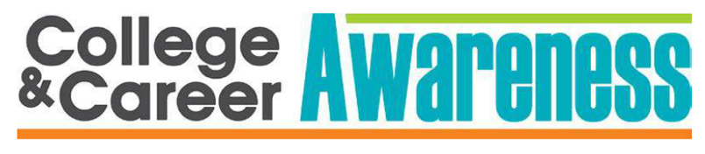

**Welcome Back Students!**

*MC900031091[1]*

***Course Description:* We’re excited to get to know each of you in the College & Career Awareness class! This course is designed to prepare students for high skill/demand jobs and to provide students the proper educational pathways to a satisfying and rewarding career. Right now is the time for students to begin preparing for their future! Through application-based lessons, students determine their talents, aspirations, goals, career interests, values, and self-identity; giving them the knowledge and direction for making informed educational & career choices.**

***Our Team &Areas of Study:* The RMMS College and Career Awareness team consists of three teachers and two school counselors. The course content was divided based on the strengths & talents of our diverse CTE Team. Each trimester students will receive a new Awareness teacher. After twelve weeks of instruction, students will then rotate to another teacher to continue the full-year course. The school counselors will intermittently be visiting teacher’s classrooms to teach specific career lessons and to assist students in career awareness and guidance.**

**College & Career Awareness Team:**

[Christian.jones@wasatch.edu](mailto:christian.jones@wasatch.edu) (teacher)

[Emily.Willardson@wasatch.edu](mailto:Emily.Willardson@wasatch.edu) (teacher)

[Kirk.heaton@wasatch.edu](mailto:Kirk.heaton@wasatch.edu) (teacher)

[Lynette.schiess@wasatch.edu](mailto:Lynette.schiess@wasatch.edu) (counselor)

[Camille.rhees@wasatch.edu](mailto:Camille.rhees@wasatch.edu) (counselor)

* **Agriculture: (CTE Team)**
* **Business & Marketing: (Mr. Jones)**
* **Family & Consumer Science: (Ms. Willardson)**
* **Health Education: (Ms. Willardson)**
* **Information Technology: (Mr. Jones)**
* **Skilled & Technical Science: (Mr. Heaton)**
* **Technology & Engineering: (Mr. Heaton)**

***Grading:*** Students will complete a variety of activities in the areas mentioned above. Points will be awarded in the district Student Information System (SIS) weekly based upon projects, activities & additional assignments. Parents, please monitor your student’s grades on SIS and Wasatch Canvas to provide support & encouragement to your son/daughter. Citizenship grades will be awarded primarily on a student’s respect to the teacher, students & facility, and adherence to class & school rules. Grades will be calculated by weighting assessments as 30% of the final grade and classwork as 70% of the final grade. A portion of the grade will also be calculated based on the student’s ability to develop characteristics that will make the successful in the workplace. These characteristics include, but are not limited to, punctuality, attendance, responsibility, dependability, productivity, high-quality work, and self-initiative. Below is the academic grading scale:

A 92.5 B   82.5 C   72.5 D  62.5

A- 89.5 B- 79.5 C- 69.5 D- 59.5

MCj02521770000[1]B+ 86.5 C+ 76.5 D+ 66.5 F 59.49 or below

------------------------------------------------------------------------------------------------------------------------------------------------------------------

***Parents:*** Thank you for entrusting us with the education of your child. We look forward to getting to know your student and sincerely hope that they will find success here at RMMS. Please sign below to indicate you have read this disclosure and send this back to school with your student. (20 pts) Please feel free to contact any of us for any questions or concerns. -*College & Career Awareness Team* **Period** (B2) (B3) (G1)

**Student (print):__________________________Parent (sign): __________________________ Date:_______**

**Garrett Jones Kirk Heaton Emily Willardson**